Autumn 1
Week 1 | Week 2 | Week 3 | Week 4 | Week 5 | Week 6 | Week 7
 | 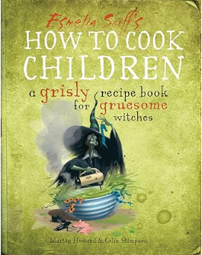
Sentence level | Instructions |  | Incidental writing: Character description and Diary Entry  Main Writing: An alternative narrative ending (including dialogue)
Autumn 2
Week 1 | Week 2 | Week 3 | Week 4 | Week 5 | Week 6 | Week 7
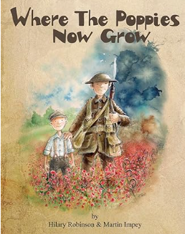 | 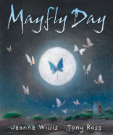  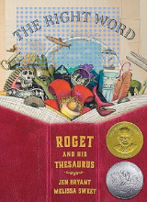  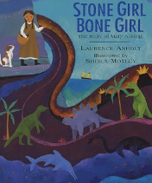 |  | 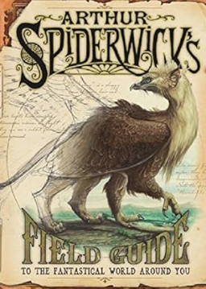
Cinquain Poetry | Recount - biography |  | Incidental writing: recount (diary entry), newspaper report  Main writing: non-chronological report.

Spring 1
Week 1 | Week 2 | Week 3 | Week 4 | Week 5 | Week 6 | Week 7
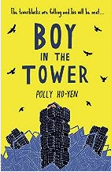
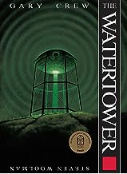

Moderation piece: Diary entry
Moderation piece: Newspaper report
Moderation piece: narrative
Spring 2
Week 1 | Week 2 | Week 3 | Week 4 | Week 5 | Moderation pieces:  2x Narrative (1 full story)  Non-chronological report  Biography  Diary entry  Newspaper report
 |  | 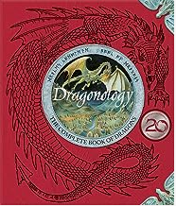
Continuation from Spring 1 (see above) |  | Moderation piece: Non-chronological report  (base on planning for Non Chron Aut 2)

Summer 1
Week 1 | Week 2 | Week 3 | Week 4 |  |  | Week 5 |  | Week 6 |  | 17/5 LA inform schools re: external moderation visit  3/6-28/6 LA undertake external moderation of writing  28/6 Deadline: submit KS2 TA
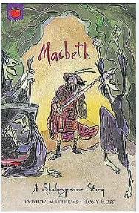

Moderation piece: Narrative – Macbeth  (See example in exemplification materials p17-21) |  |  |  | SATS |  |  | Moderation piece: biography  Base on biography planning Aut 2
Summer 2
Week 1 | Week 2 | Week 3 | Week 4 |  |  | Week 5 |  | Week 6 |  | Week 7
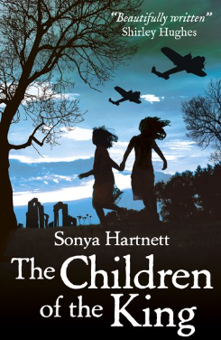

Incidental writing: argument (for and against evacuation), letter  Main writing: persuasive speech |  |  |  |  | Incidental writing: book review, radio interview  Main writing: Explanation (how to survive)

